
SUPREME KNOWLEDGE FOUNDATION GROUP OF INSTITUTIONS
EVENT MANAGEMENT WEBSITE
NAME | : | Sayan Maity
ROLL NO | : | 25342724078
STREAM | : | BCA
SEMESTER | : | 5th
YEAR | : | 2024 - 25
SUBJECT | : | PHP with MySQL LAB
SUB CODE | : | BCAC391

ABSTRACT
Colleges organise many events every year – technical fests, cultural nights, sports meets and quizzes – but announcements and registrations are often handled on notice boards and paper lists. This project, the Event Management Website, is a full-stack web application built with PHP and MySQL that lets an administrator publish and manage events online and lets students browse those events and participate in them.
The objectives of the project were: (i) to design a simple relational database for students, events and participations; (ii) to implement PHP scripts that perform the four CRUD operations – Create, Read, Update and Delete – on events through the MySQLi extension; (iii) to apply basic business rules such as one participation per student per event and a limit on available seats; and (iv) to deliver a bright, responsive interface using Bootstrap 5.
The outcome is a working two-sided system. The Admin can log in to an Admin Panel to add, edit and delete events and to see who has joined each event. Students can register, log in, view all upcoming events, participate in them and cancel their participation. The system was tested with sample data and every CRUD operation was verified; the results are shown with screenshots in Section 4.

3. SYSTEM FEATURES & FUNCTIONALITIES

3.1 Introduction
The Event Management Website replaces manual event handling with a small database-driven web application. All data is stored in a MySQL database and every page is a PHP script that reads from or writes to that database.
The application has two kinds of users. The Admin manages the events. A Student can view events and participate in them. The two kinds of users log in separately and see different pages.

3.2 Technology Stack
Layer | Technology | Purpose
Front end | HTML5, CSS3, Bootstrap 5.3 (CDN), Bootstrap Icons | Colourful responsive layout, cards, forms and tables
Back end | PHP 8 (procedural style) | Page logic, sessions, form handling
Database | MySQL via the MySQLi extension | Permanent storage of records
Server | Apache (XAMPP / WAMP) | Runs PHP and serves pages
Tools | phpMyAdmin, Google Chrome | Importing database.sql, testing

3.3 Core Modules
- Student Registration & Login – students create an account with name, roll number, department, semester and password and then log in with roll number and password.
- Event Listing – the home page shows all upcoming events as cards with category, date, time, venue and seats left.
- Event Details & Participation – each event has a detail page with a Participate button.
- My Events – shows the events a student has joined and allows cancelling participation.
- Admin Login – separate login for the administrator.
- Admin Dashboard – shows total events, students and registrations with a table of all events.
- Event Management (CRUD) – the admin can add, edit and delete events.
- Participants List – the admin can see the students registered for any event.

3.4 Business Logic
- Only logged-in students can participate; others are sent to the login page.
- A student cannot participate twice in the same event – the system checks the participants table first.
- Seats left = total seats minus the number of participants. When it reaches zero, participation is refused.
- Deleting an event also deletes its participation records so no orphan rows are left.
- Admin pages check the admin session at the top and redirect to the admin login if it is missing.

3.5 Database Design
The database event_db contains four tables. Every table uses an auto-incrementing integer primary key named id. Relationships are kept by storing the id of the related row (a foreign-key style column).
Table: users
Column | Type | Description
id | INT, PK, AUTO_INCREMENT | Unique student id
name | VARCHAR(100) | Full name
roll_no | VARCHAR(30) | University roll number, used to log in
department | VARCHAR(30) | BCA, BBA, BSc, etc.
semester | INT | Current semester
password | VARCHAR(50) | Login password

Table: events
Column | Type | Description
id | INT, PK, AUTO_INCREMENT | Unique event id
title | VARCHAR(150) | Event name
description | TEXT | Details of the event
venue | VARCHAR(100) | Where it takes place
event_date | DATE | Date of the event
event_time | VARCHAR(20) | Start time, e.g. 10:00 AM
seats | INT | Total seats
category | VARCHAR(30) | Technical, Cultural, Sports, Academic

Table: participants
Column | Type | Description
id | INT, PK, AUTO_INCREMENT | Unique record id
user_id | INT | Student who joined (refers to users.id)
event_id | INT | Event joined (refers to events.id)
registered_on | DATE | Date of registration

Table: admins
Column | Type | Description
id | INT, PK, AUTO_INCREMENT | Unique admin id
username | VARCHAR(50) | Admin username
password | VARCHAR(50) | Admin password

Entity–Relationship summary
- One student can join many events and one event can have many students – a many-to-many relationship resolved by the participants table.
- users (1) —— (N) participants (N) —— (1) events.
- admins is independent and is used only for the Admin Panel login.

3.6 Limitations & Future Scope
- Passwords are stored as plain text and user input is not sanitised, because the project is kept deliberately basic for learning; a real system should use password_hash() and prepared statements.
- Future work: event images, e-mail confirmation, QR-code tickets, search and filters, and certificates for participants.

4. MODULE DESCRIPTION & SCREENSHOTS

4.1 Execution Flow
- The user opens index.php, which lists the upcoming events from the events table.
- A student registers (register.php) or logs in (login.php); the roll number is stored in the session.
- The student opens an event (event.php) and presses Participate (participate.php), which inserts a row in participants.
- my_events.php lists the student's events and cancel.php removes a participation.
- The admin logs in at admin/login.php and works in the Admin Panel: index.php (dashboard), add_event.php, edit_event.php, delete_event.php and participants.php.

4.2 Student Registration & Login Module
New students fill the registration form; existing students log in with their roll number and password.
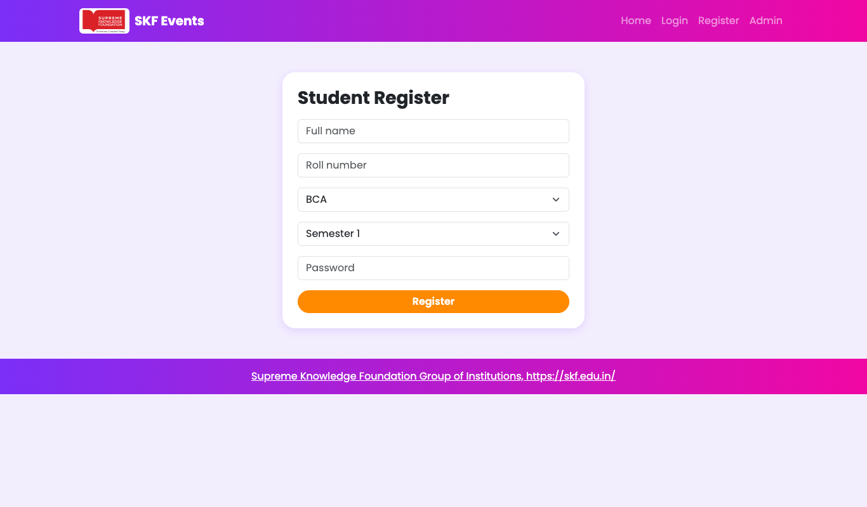
Figure 1: Student registration page
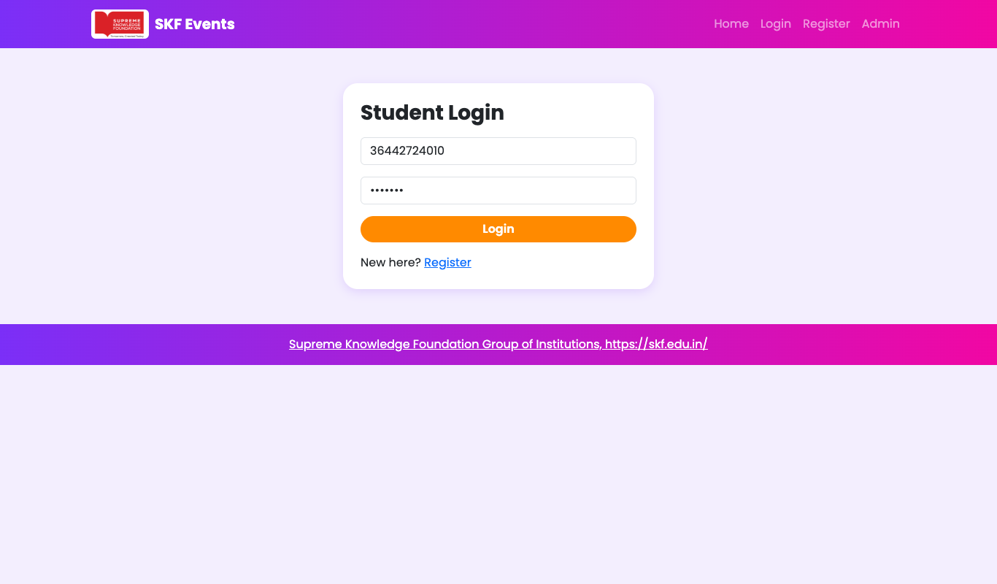
Figure 2: Student login page

4.3 Event Listing Module
After login, the home page shows every upcoming event as a card together with its category badge, date, time, venue and the number of seats left.
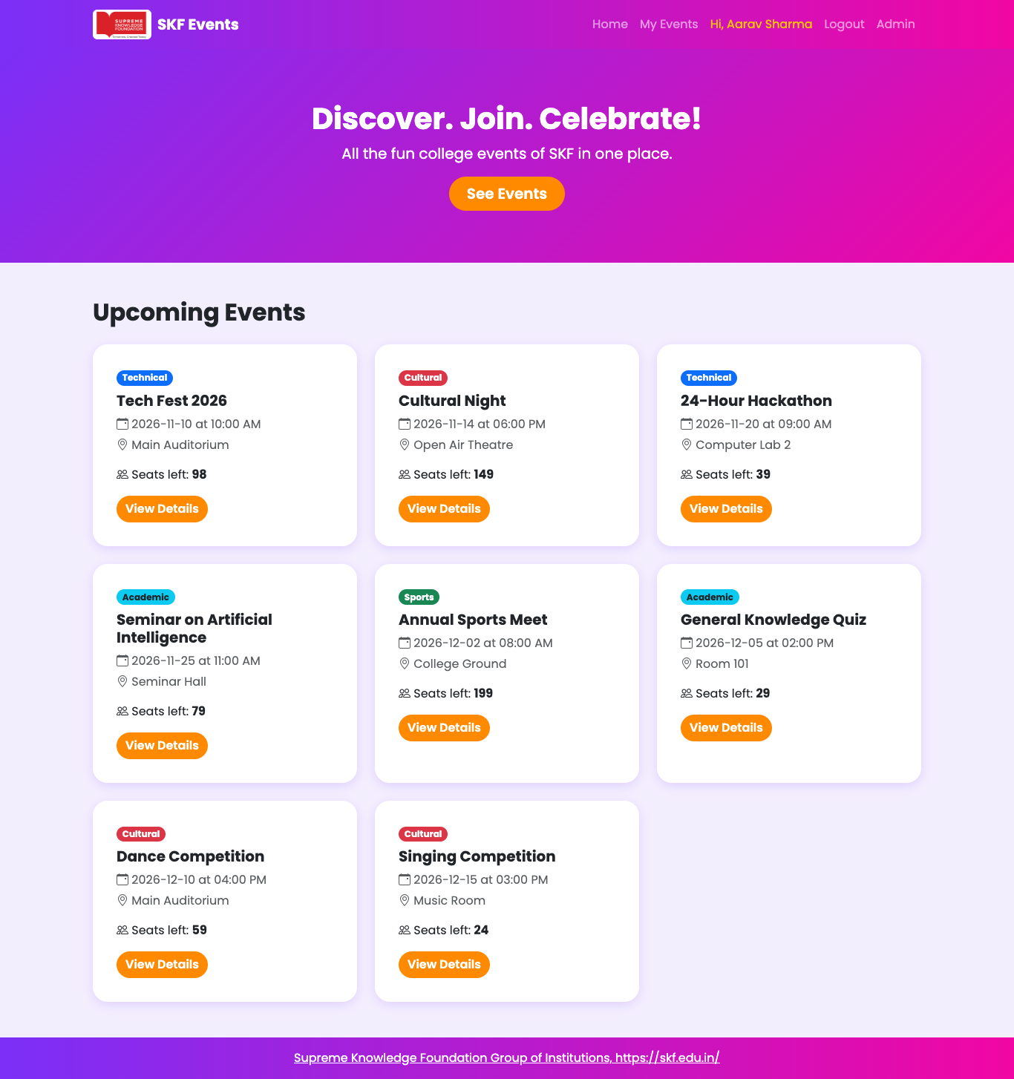
Figure 3: Home page with upcoming events

4.4 Event Details and Participation Module
The detail page shows the full description. Pressing Participate adds the student to the event.
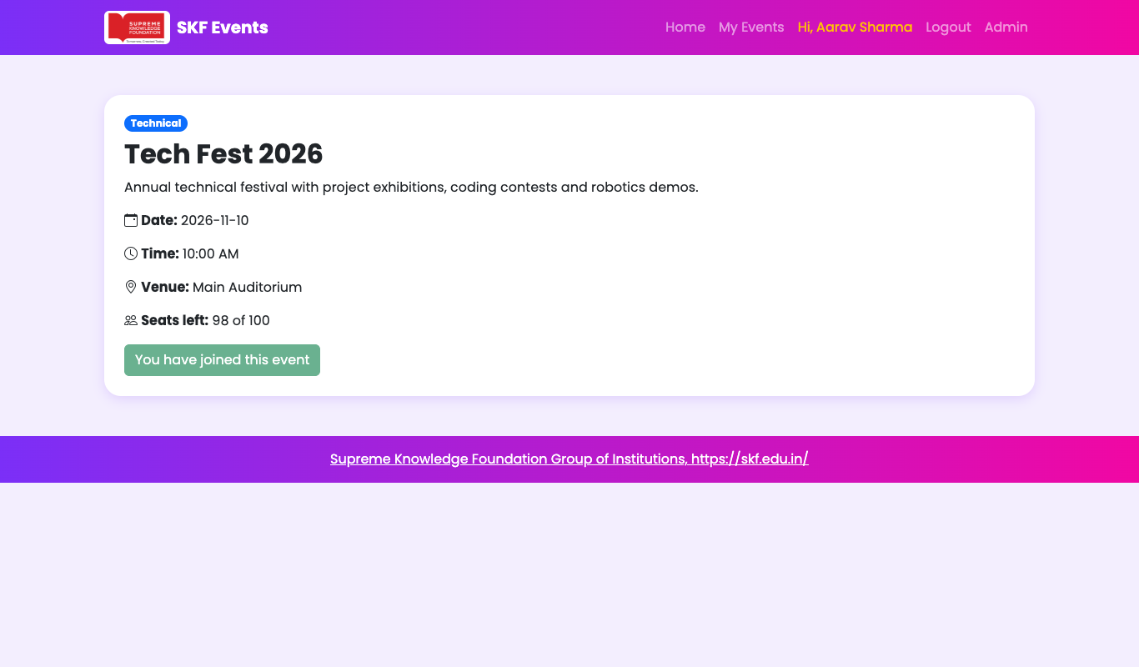
Figure 4: Event details page
Figure 5: Participation confirmed
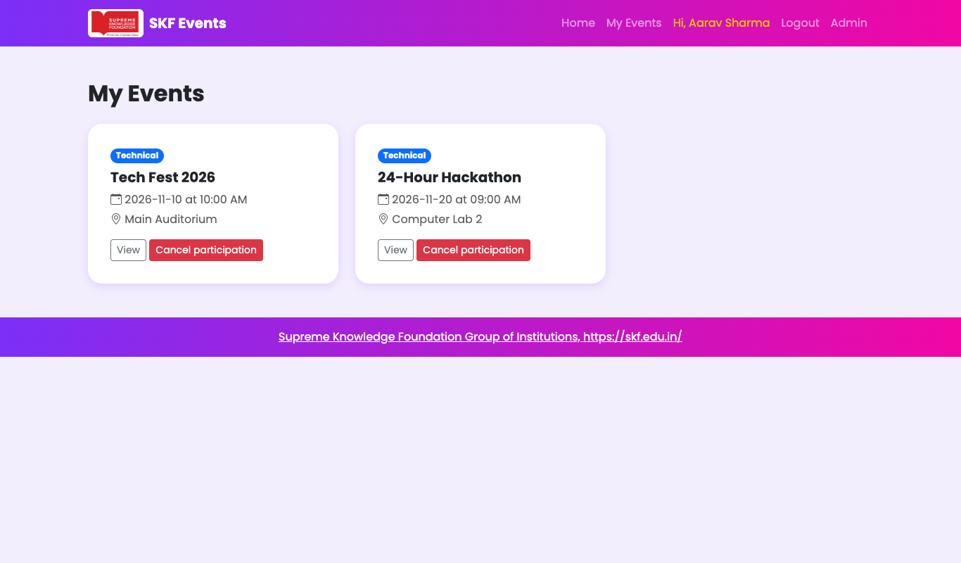
Figure 6: My Events page

4.5 Admin Login and Dashboard Module
The admin signs in with a separate login and lands on a dashboard showing summary counts and the list of all events with Participants, Edit and Delete buttons.
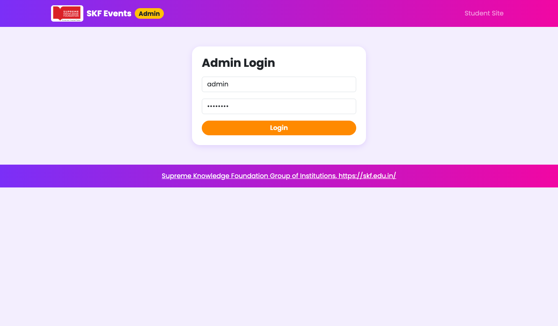
Figure 7: Admin login page
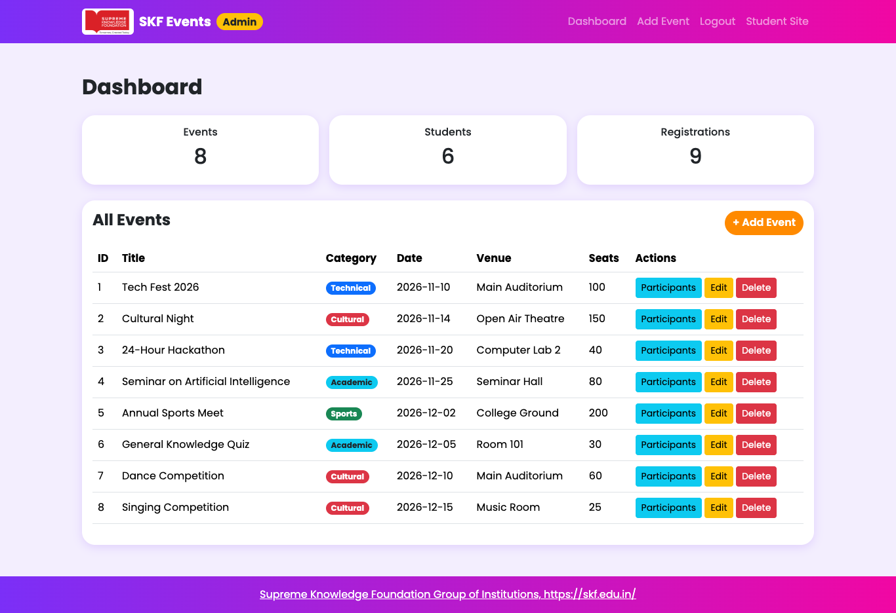
Figure 8: Admin dashboard

4.6 Verification of CRUD Operations
The four CRUD operations were tested in the Admin Panel using sample data. A new event "Poster Making Contest" was created, edited and finally deleted.
Operation | SQL statement used | Page | Result
Create | INSERT INTO events (...) VALUES (...) | admin/add_event.php | New event appears in dashboard
Read | SELECT * FROM events | index.php, admin/index.php | All events listed
Update | UPDATE events SET ... WHERE id= | admin/edit_event.php | Title and seats changed
Delete | DELETE FROM events WHERE id= | admin/delete_event.php | Event removed from list

Create – the admin fills the Add Event form and the event is added to the list.
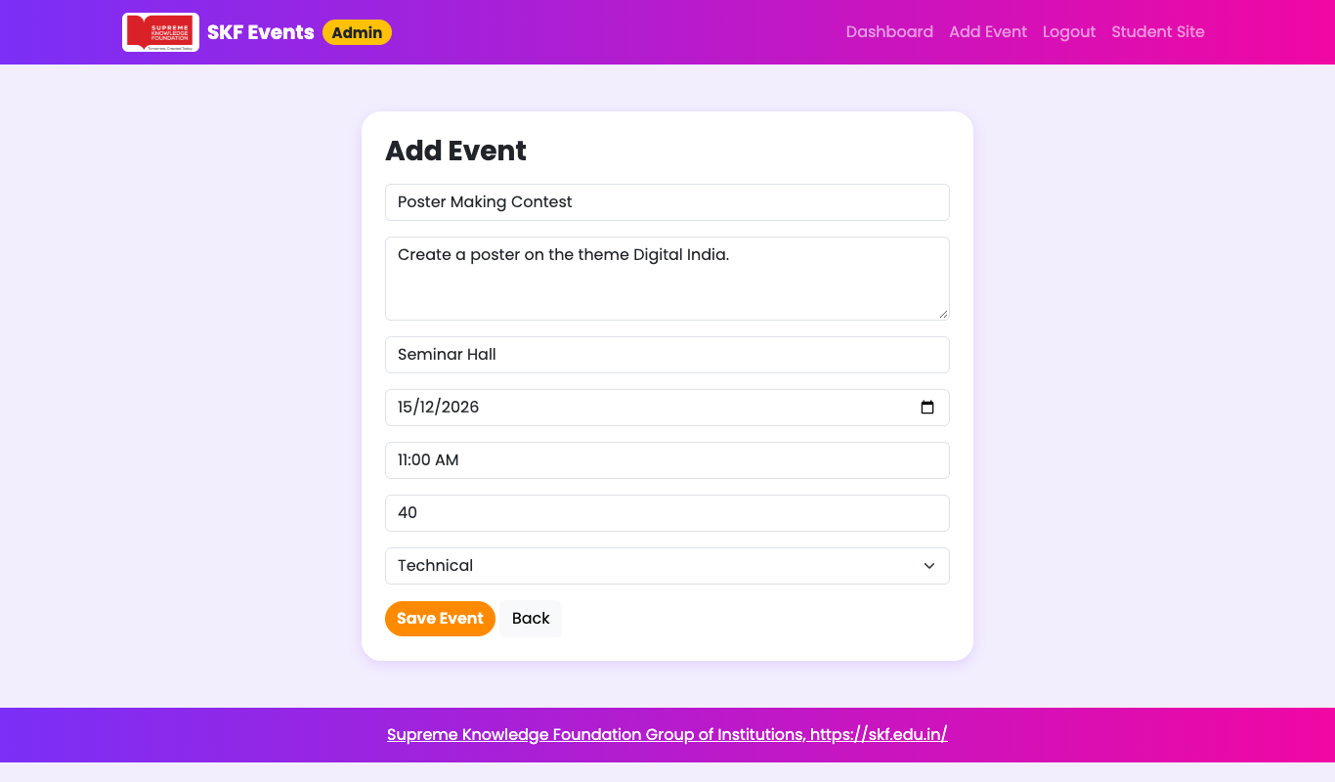
Figure 9: Add Event form (Create)
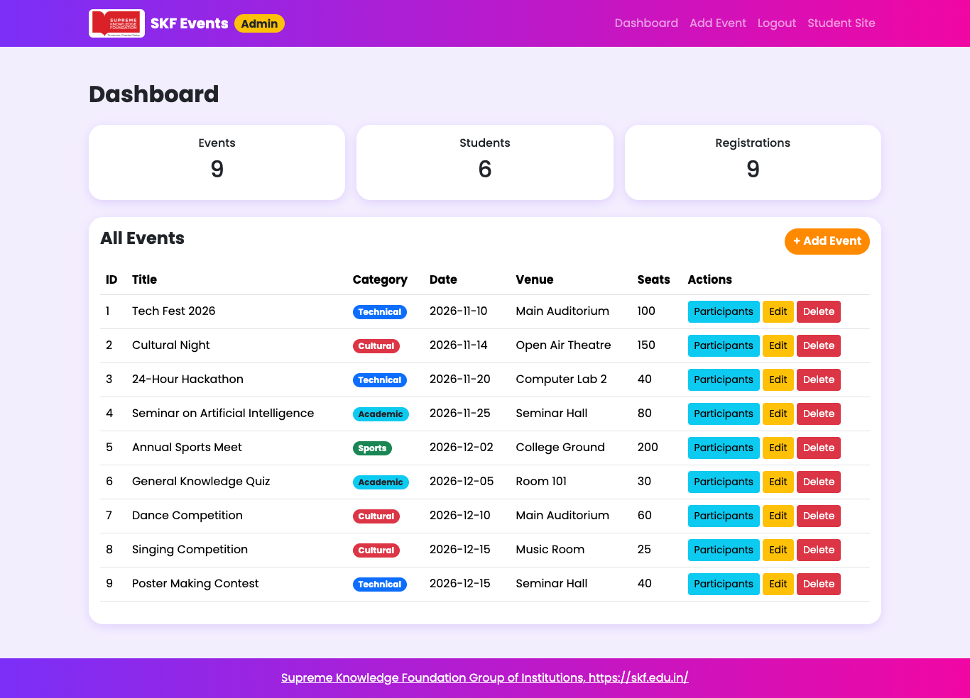
Figure 10: Dashboard showing the new event
Update – the admin opens the Edit page, changes the title and number of seats and saves.
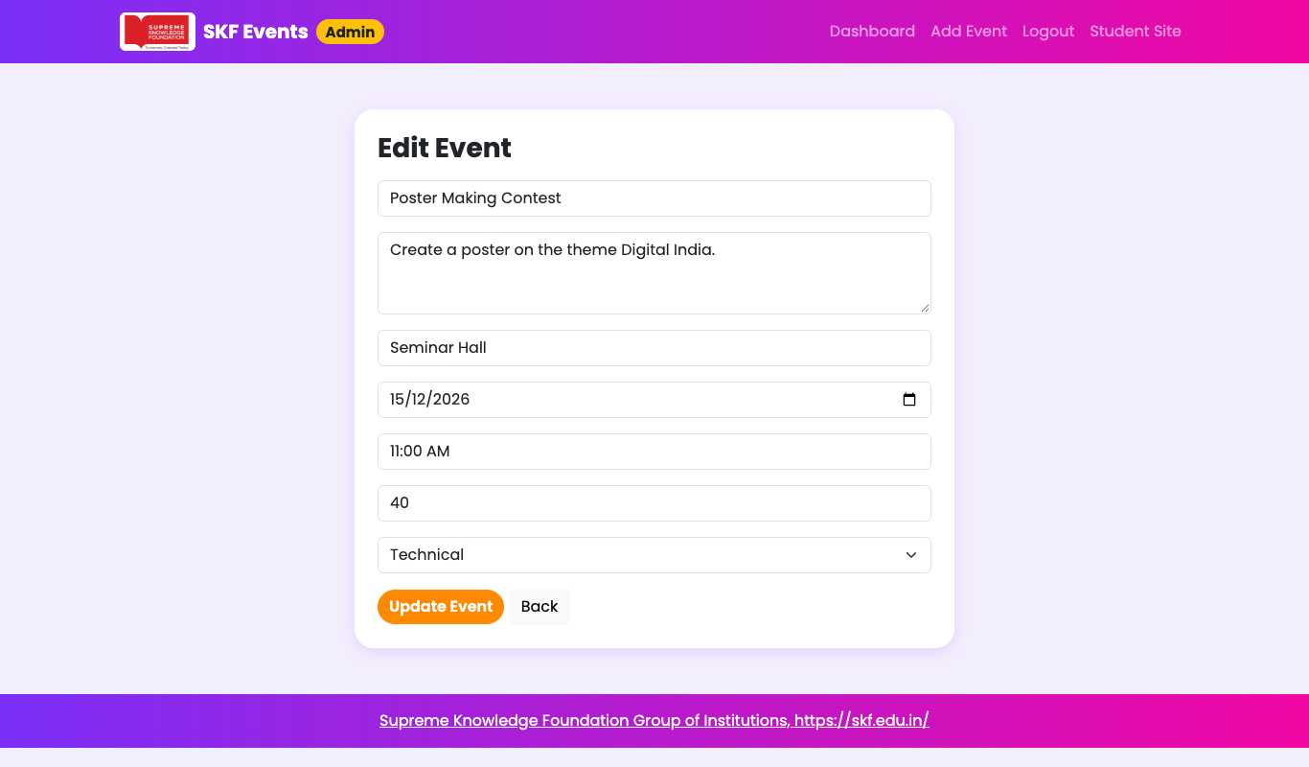
Figure 11: Edit Event form (Update)
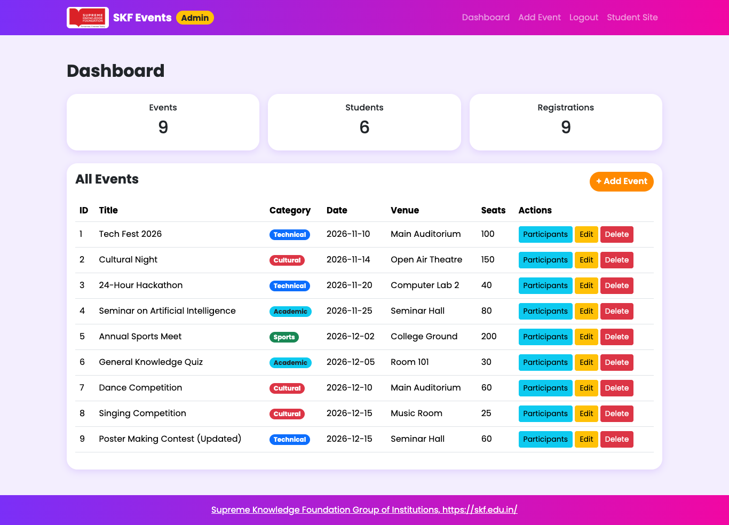
Figure 12: Dashboard after update
Read – the participants page lists the students who joined an event.
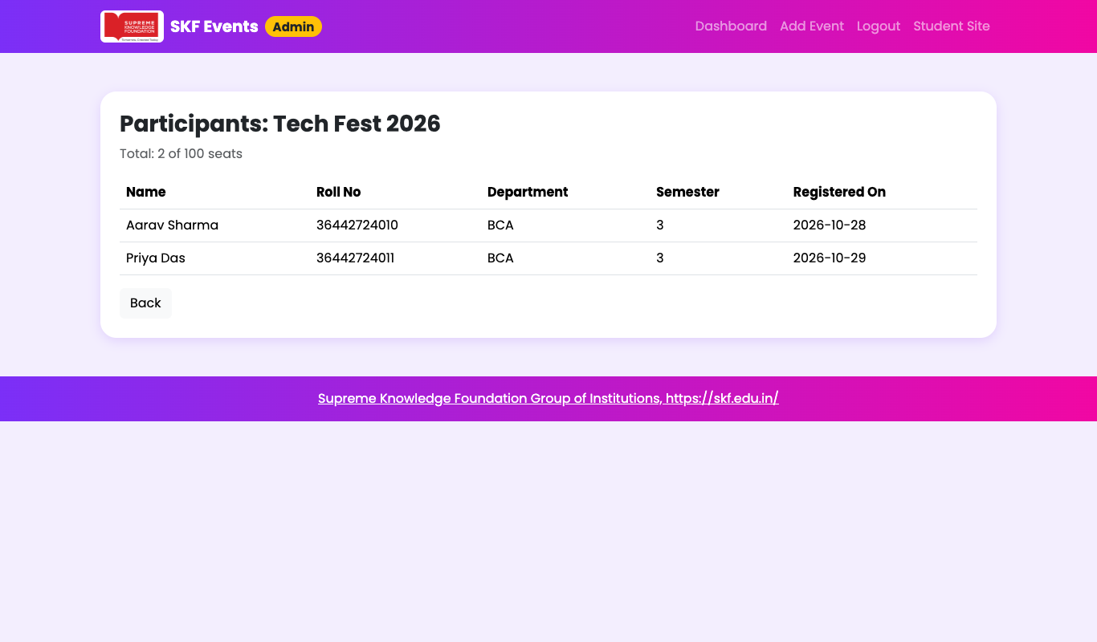
Figure 13: Participants of an event (Read)
Delete – the admin deletes the event and it disappears from the dashboard.
Figure 14: Dashboard after deleting the event (Delete)

4.7 Setup & Execution
1. Install XAMPP (or WAMP) and start the Apache and MySQL services.
2. Copy the folder event-management into the htdocs directory.
3. Open phpMyAdmin (http://localhost/phpmyadmin), choose Import and select database.sql. This creates the database and inserts the sample data.
4. Open http://localhost/event-management/ in a browser.
5. Admin login: http://localhost/event-management/admin/login.php (username: admin, password: admin123).
6. Sample student login: roll number 36442724010, password pass123.

5. SOURCE CODE
The complete source code is supplied separately in the project folder and is not reproduced in this report. The table below lists the files and their roles.
File | Role
database.sql | Creates event_db, its tables and sample data
db.php | Database connection and session start
header.php / footer.php | Common navbar and footer with college logo
index.php | Home page – list of events
event.php | Event details
participate.php / cancel.php | Join or leave an event
register.php / login.php / logout.php | Student account pages
my_events.php | Events joined by the student
admin/login.php, logout.php | Admin authentication
admin/index.php | Admin dashboard
admin/add_event.php | Create event
admin/edit_event.php | Update event
admin/delete_event.php | Delete event
admin/participants.php | Participants of an event
README.md | Setup instructions

6. REFERENCES & BIBLIOGRAPHY
[1] PHP Documentation Group, "PHP Manual", https://www.php.net/manual/en/
[2] PHP Documentation Group, "MySQL Improved Extension (MySQLi)", https://www.php.net/manual/en/book.mysqli.php
[3] Oracle Corporation, "MySQL 8.0 Reference Manual", https://dev.mysql.com/doc/refman/8.0/en/
[4] Bootstrap Team, "Bootstrap 5.3 Documentation", https://getbootstrap.com/docs/5.3/
[5] Bootstrap Team, "Bootstrap Icons", https://icons.getbootstrap.com/
[6] Google, "Google Fonts", https://fonts.google.com/
[7] Apache Friends, "XAMPP Documentation", https://www.apachefriends.org/
[8] phpMyAdmin Project, "phpMyAdmin Documentation", https://www.phpmyadmin.net/docs/
[9] W3Schools, "PHP MySQL Tutorial", https://www.w3schools.com/php/php_mysql_intro.asp
[10] Supreme Knowledge Foundation Group of Institutions, official website and logo, https://skf.edu.in/

